**Assignment - 1**

**MCQ:**

1.   c. Windows Subsystem for Linux

2.   b. cd ~

3.   b. Apt

4.   c. Network layer

5.   a. It identifies the host within a subnet.

6.   b. mkdir

7.   c. Providing a command-line interface

8.   b. Apache

9.   b. Domain Name System

10. a. Cat

**Task-Based Exercises:**

1. Task: Use the **ls** command to list all files and directories in your home directory.

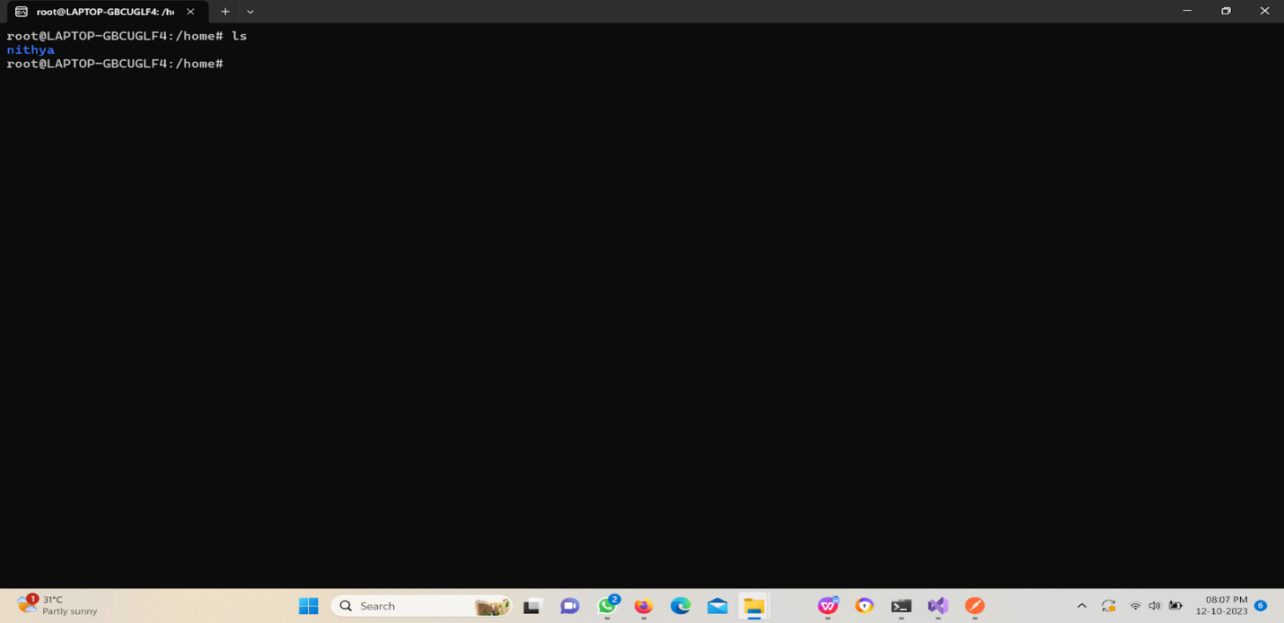

1. Task: Create a new directory called "Documents" within your home directory.

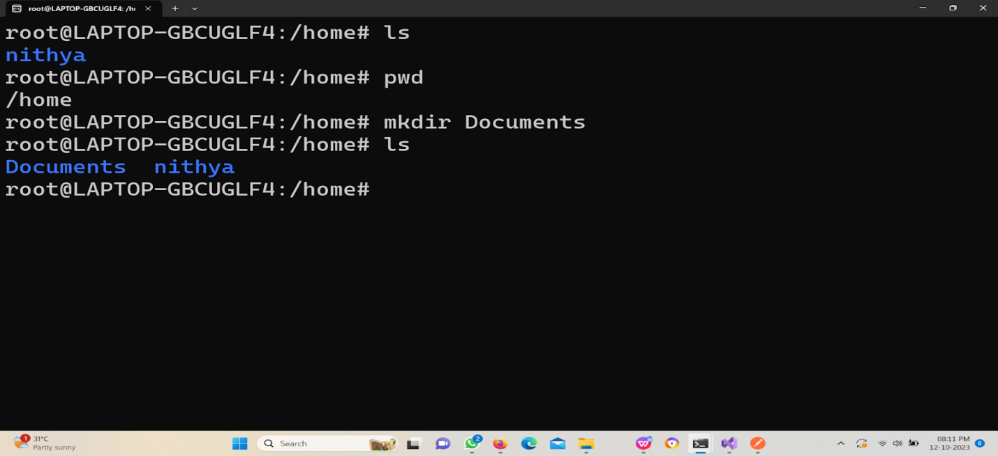

3.Task: Change the permissions of a file named "myFile.txt" to allow read and write access for the owner, and read-only access for others.

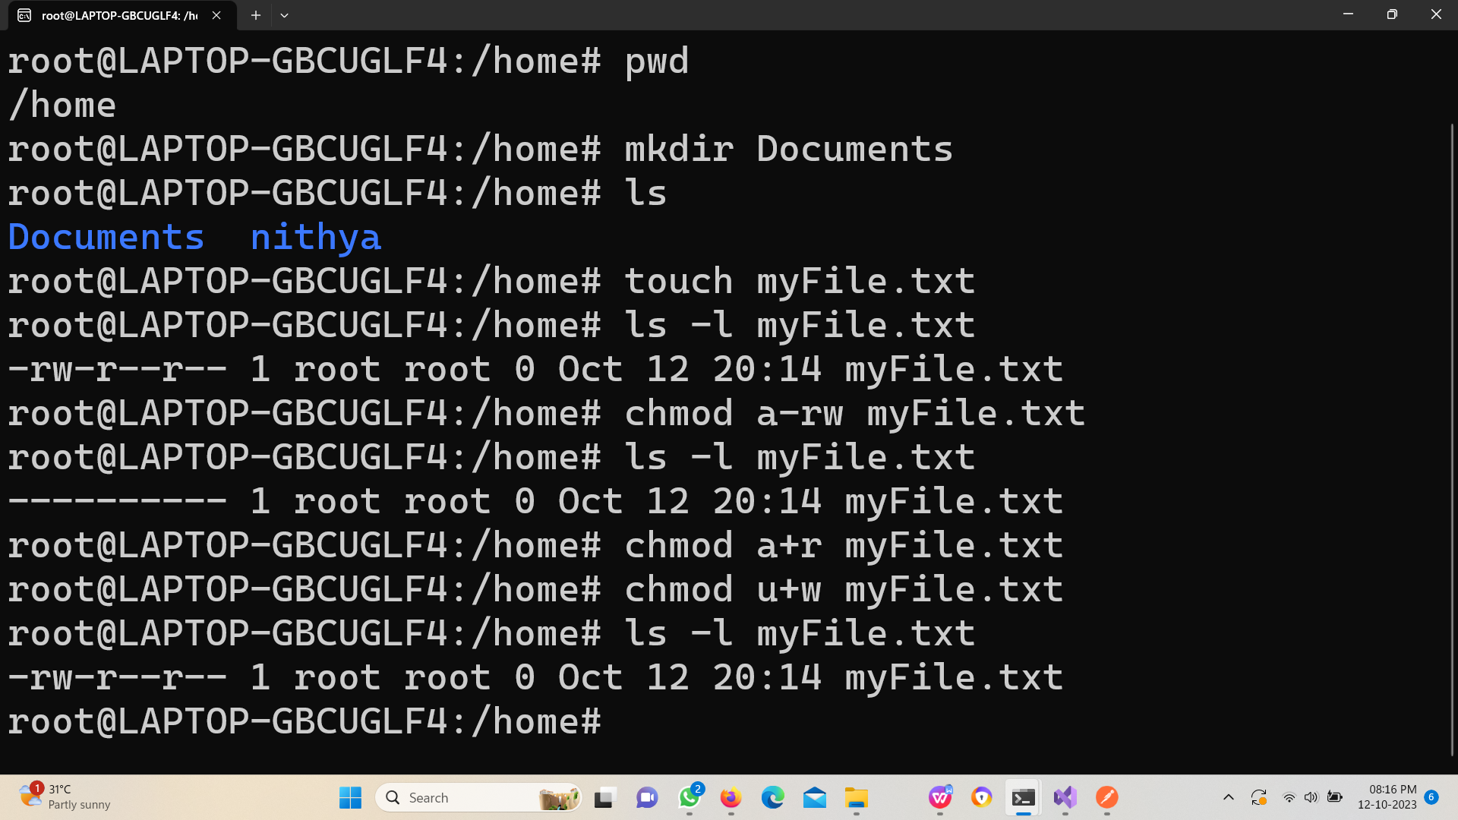

4.Task: Install a text editor of your choice on your Linux system using the appropriate package manager.

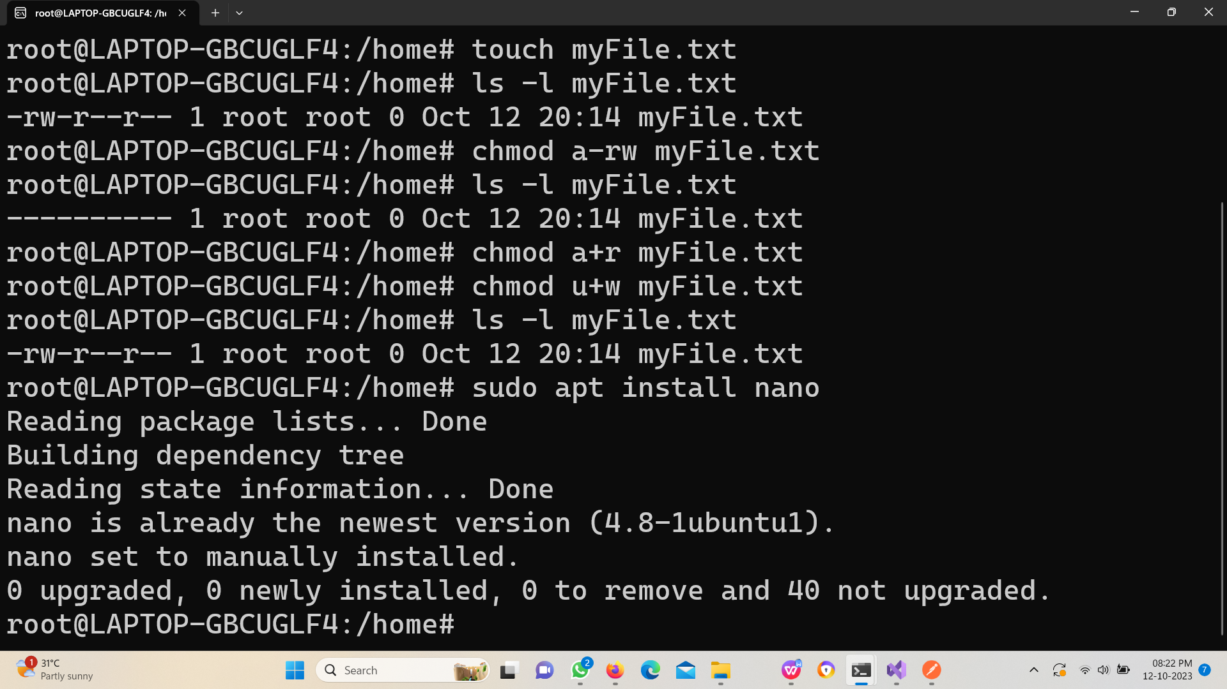

1. Task: Configure your Linux system to use Google's DNS servers (8.8.8.8 and 8.8.4.4) for DNS resolution.

**Step 1:** sudo nano /etc/resolv.conf

Open the resolv.conf file.

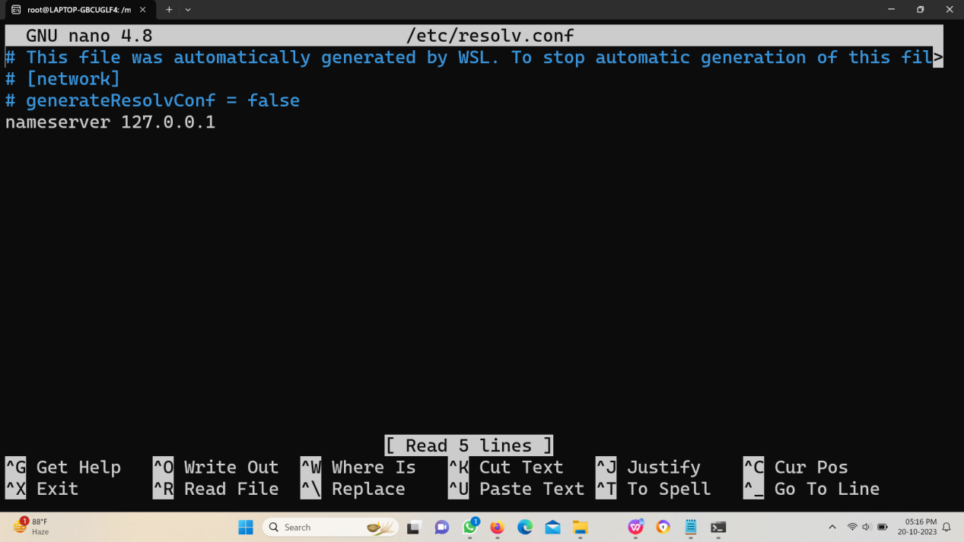

**Step 2:**

Change the address to desired. Save the file.

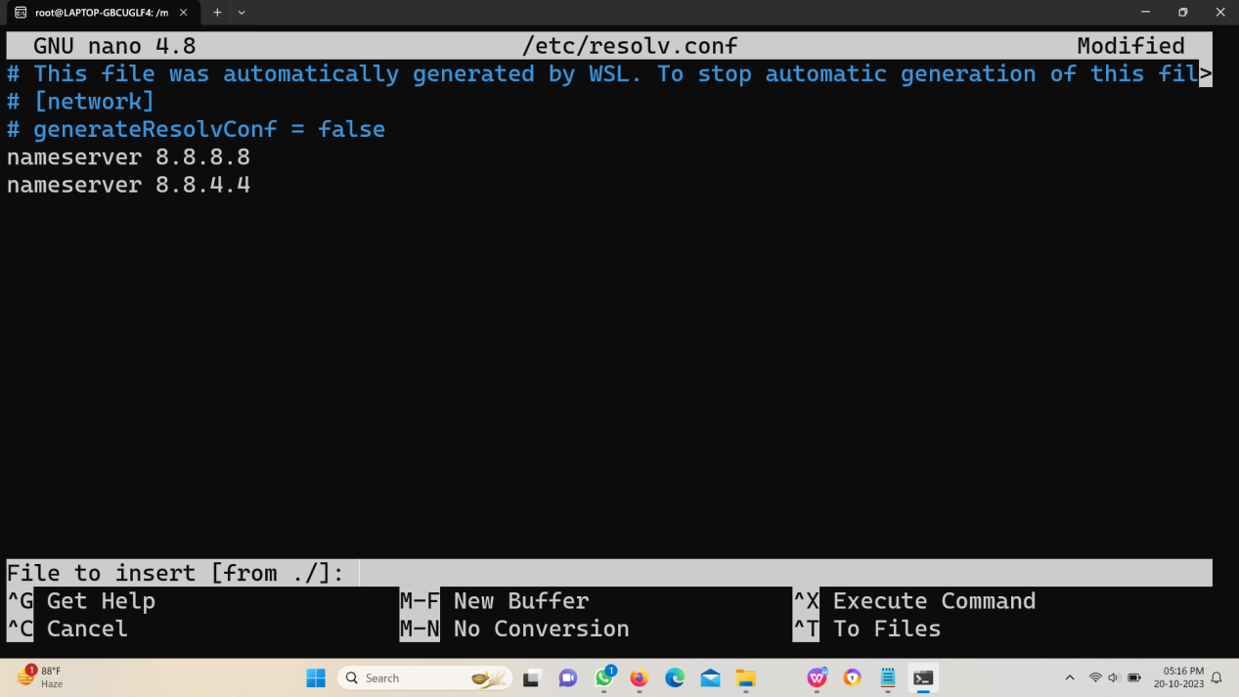

**Step 3:**

Install the network manager to restart.

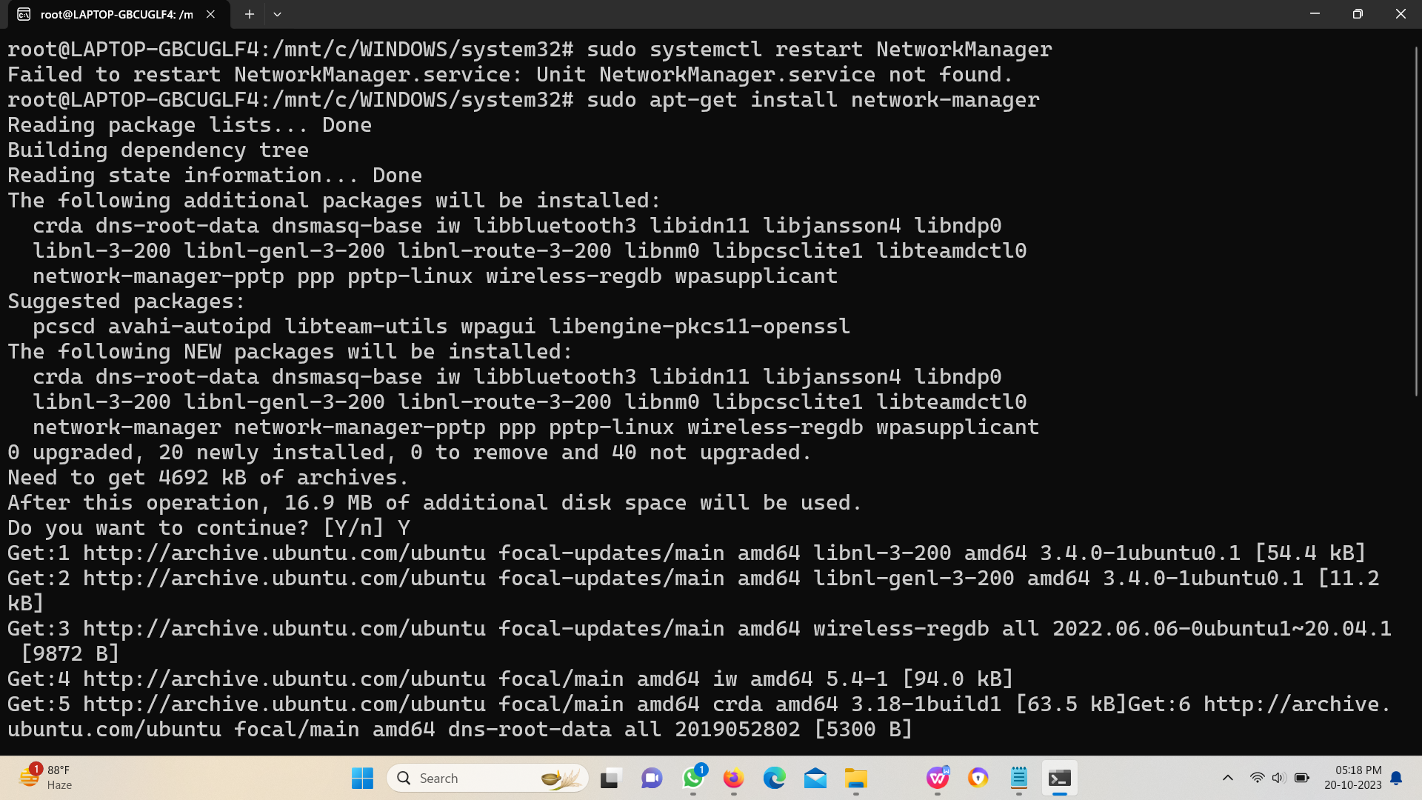

**Step 4:**

Restart. And you can review the changes in resolv.conf file.

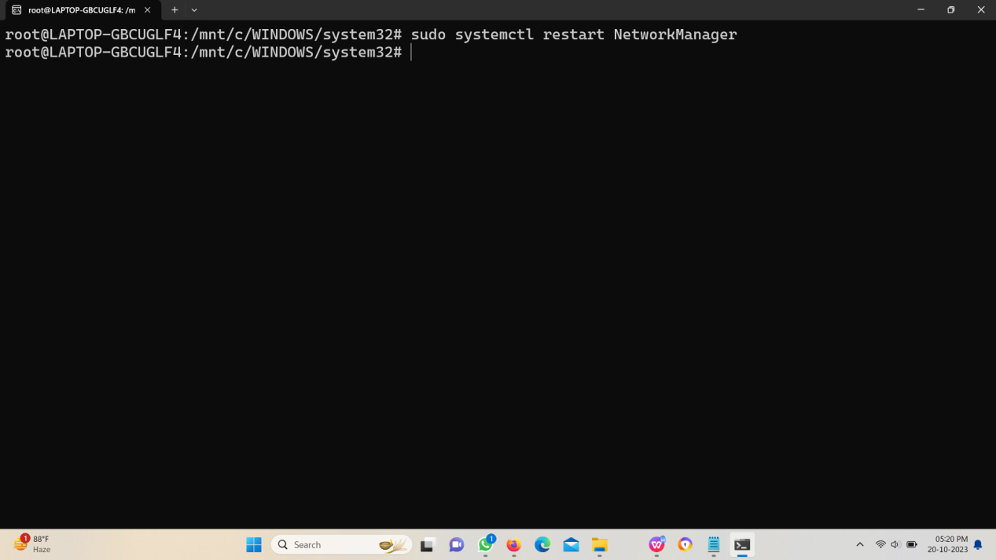

1. Task: Set up a static IP address (e.g., 192.168.1.100) on your Linux machine using the command line.

**Step 1:** Open the Yaml file.

sudo nano /etc/netplan/01-netcfg.yaml

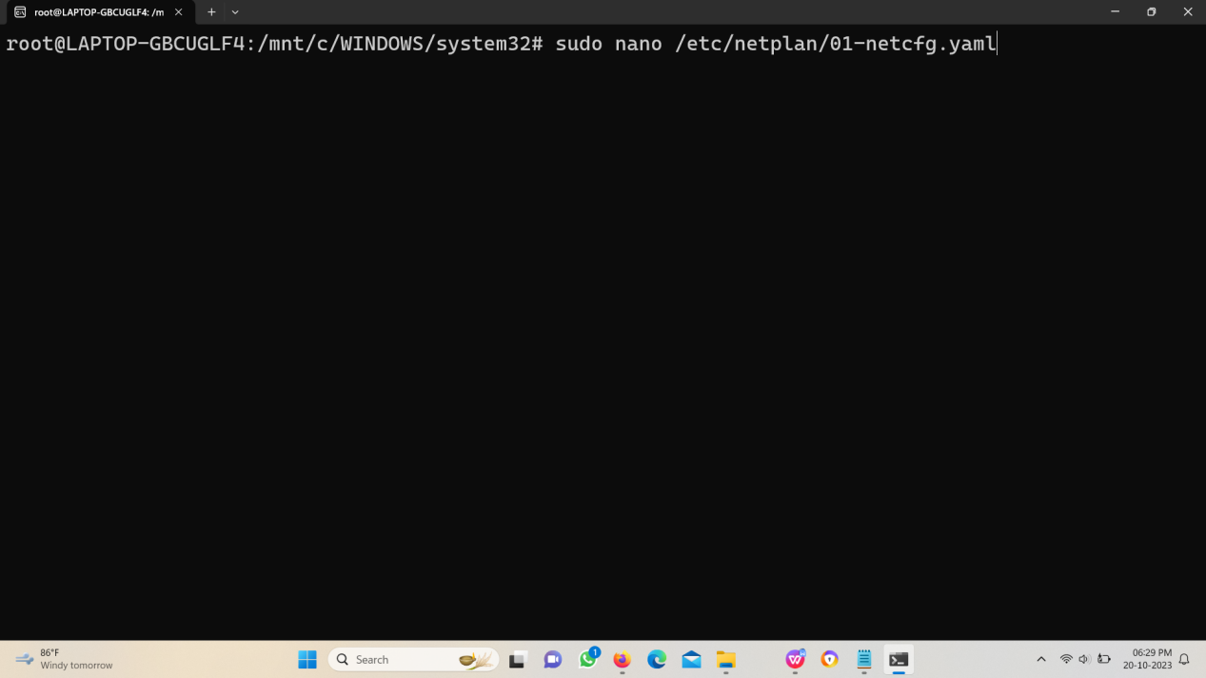

**Step 2:** Edit the Yaml file with the following code segment.

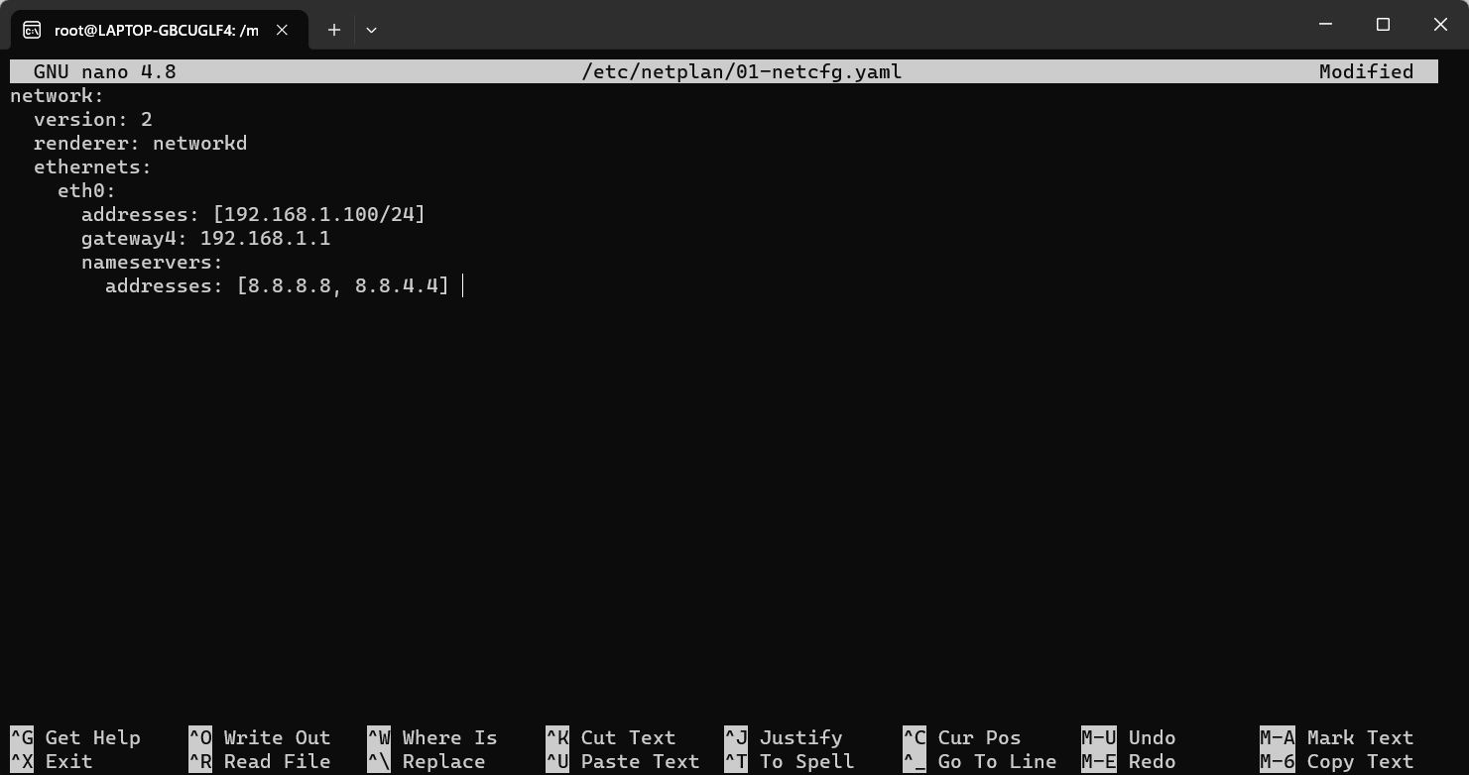

Save and exit the file.

**Step 3:** Apply the changes.

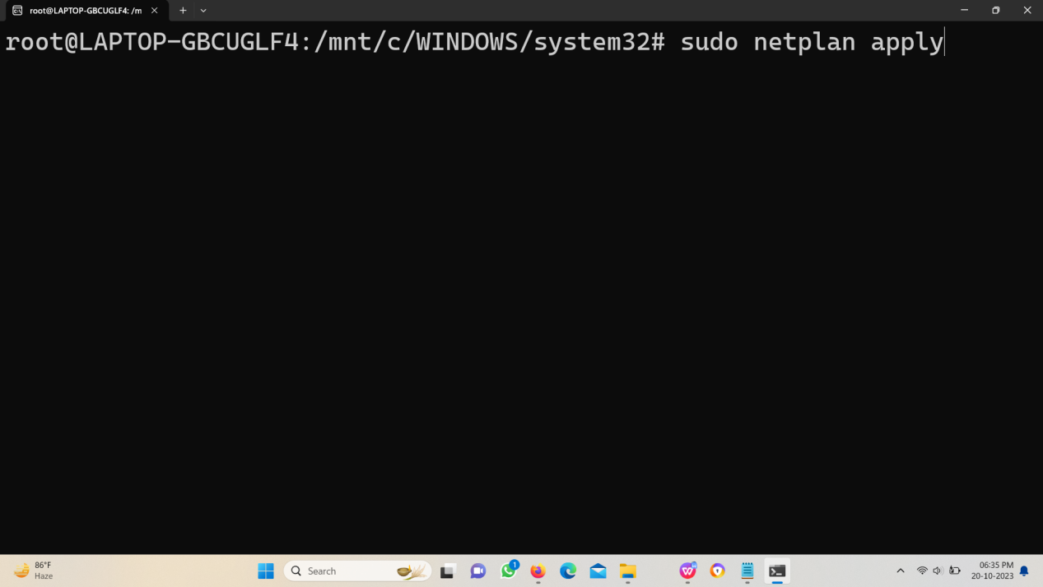

**Step 4:** Restart.

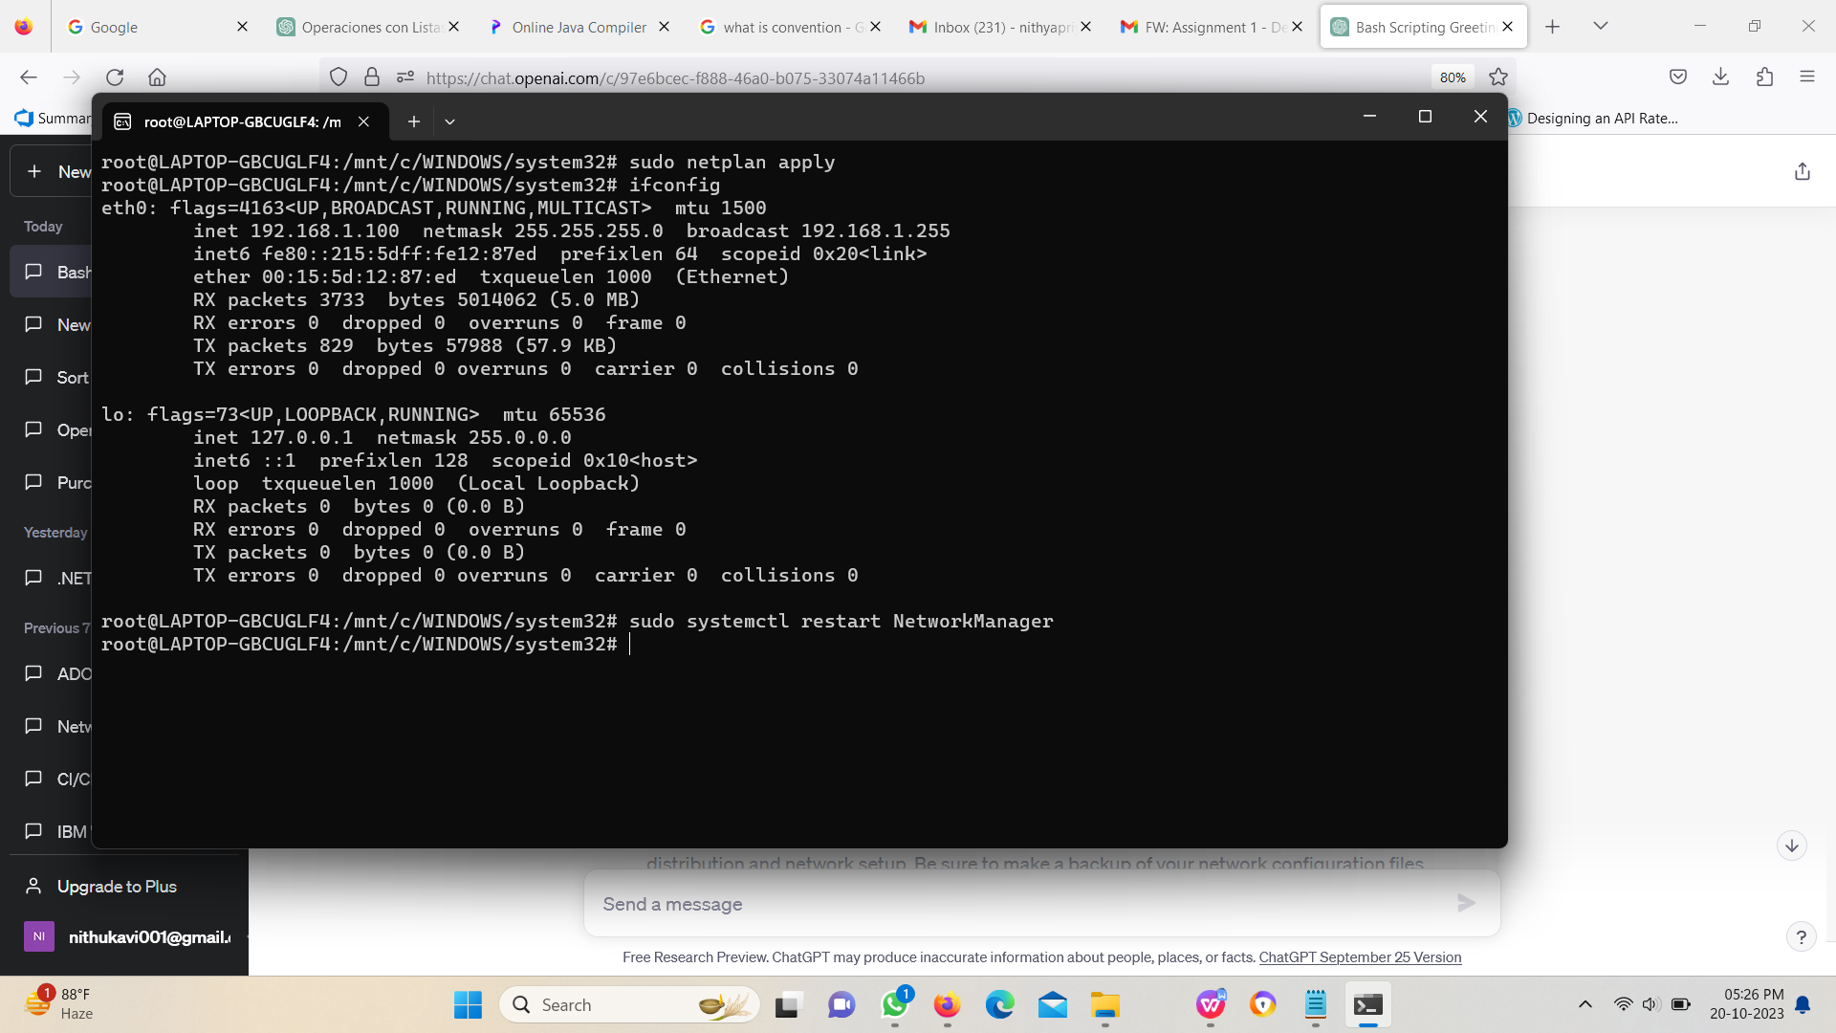

1. Task: Create a simple bash script that prints "Hello, World!" when executed.

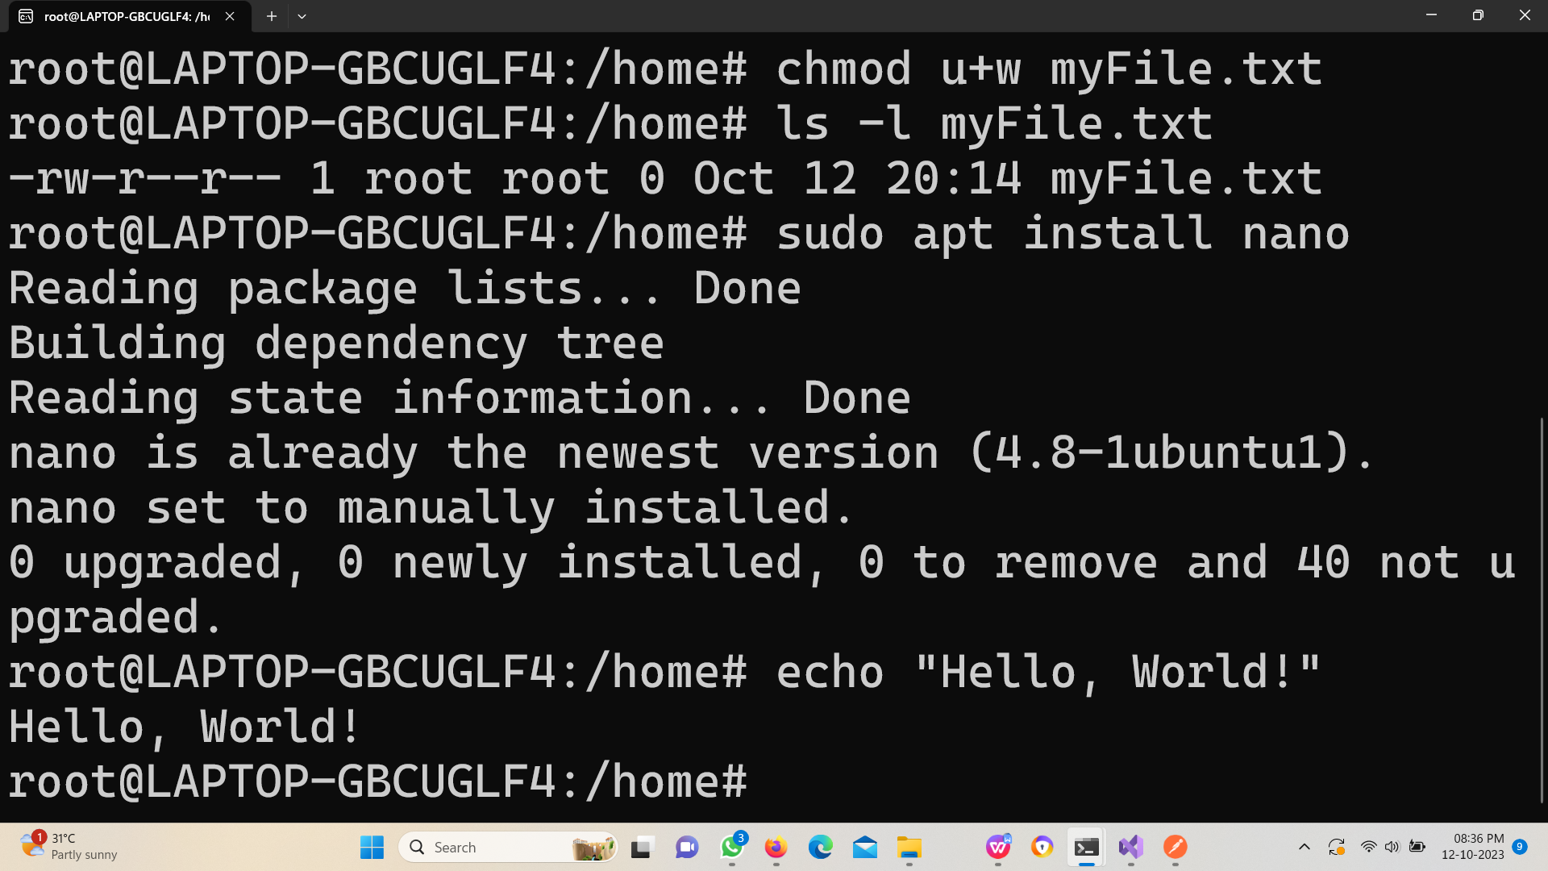

1. Task: Use the **ping** command to check the connectivity to a remote server or website (e.g., "ping [www.example.com](http://www.example.com/" \t "https://mail.google.com/mail/u/4/" \l "inbox/_blank)").

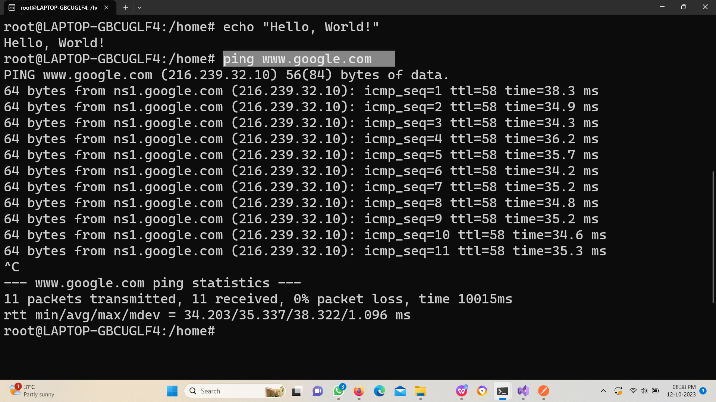

1. Task: Create a symbolic link named "mylink" that points to a file named "targetfile.txt."

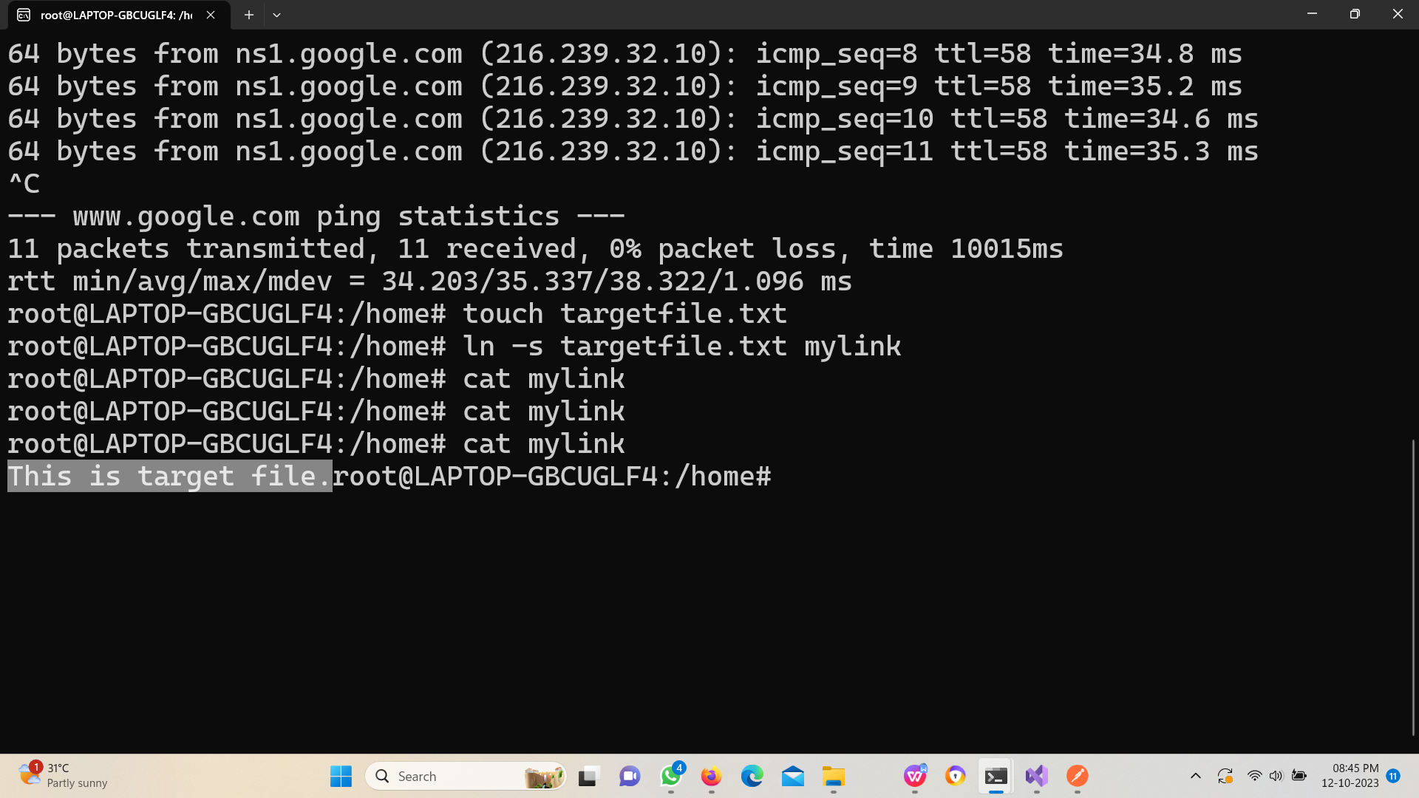

1. Task: Use the **netstat** command to display a list of open network connections on your Linux machine

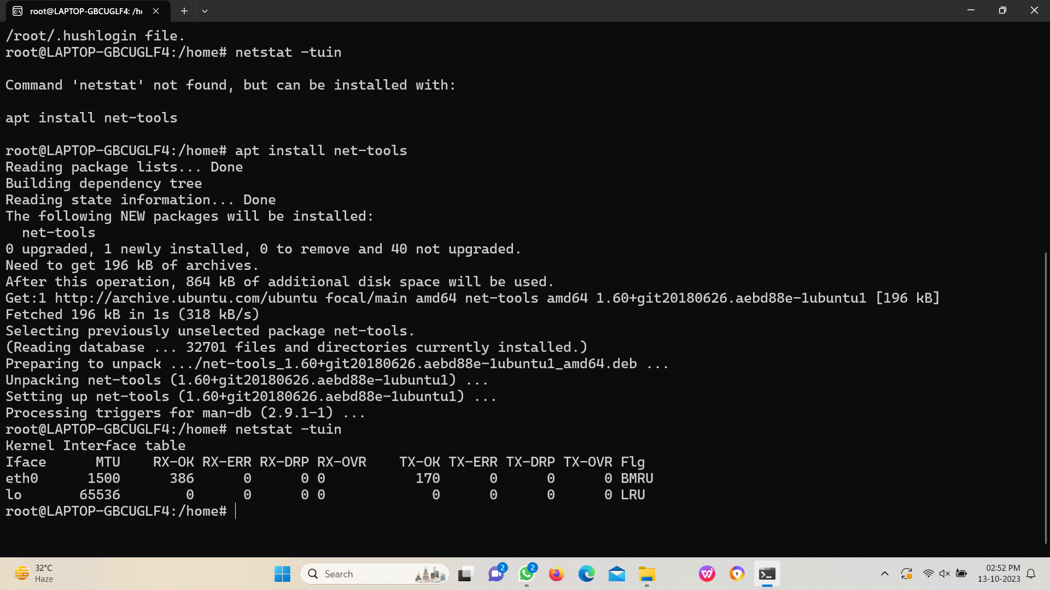

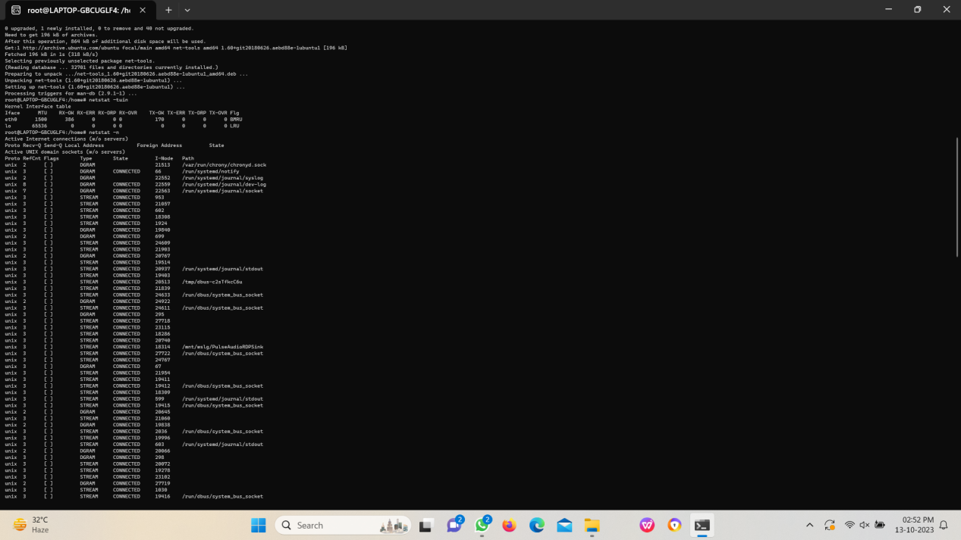

**Labs:**

**Lab 1: WSL Installation**

* Objective: Install Windows Subsystem for Linux (WSL) on your Windows machine.
* Steps: Document the installation process, and launch a Linux distribution through WSL.

**Step 1: Check whether Virtual Machine is enabled.**

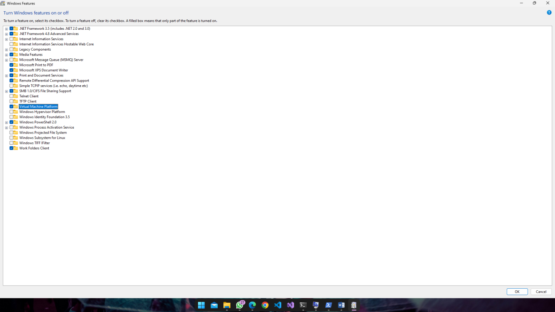

**Step 2: Search for WSL in Microsoft Store**

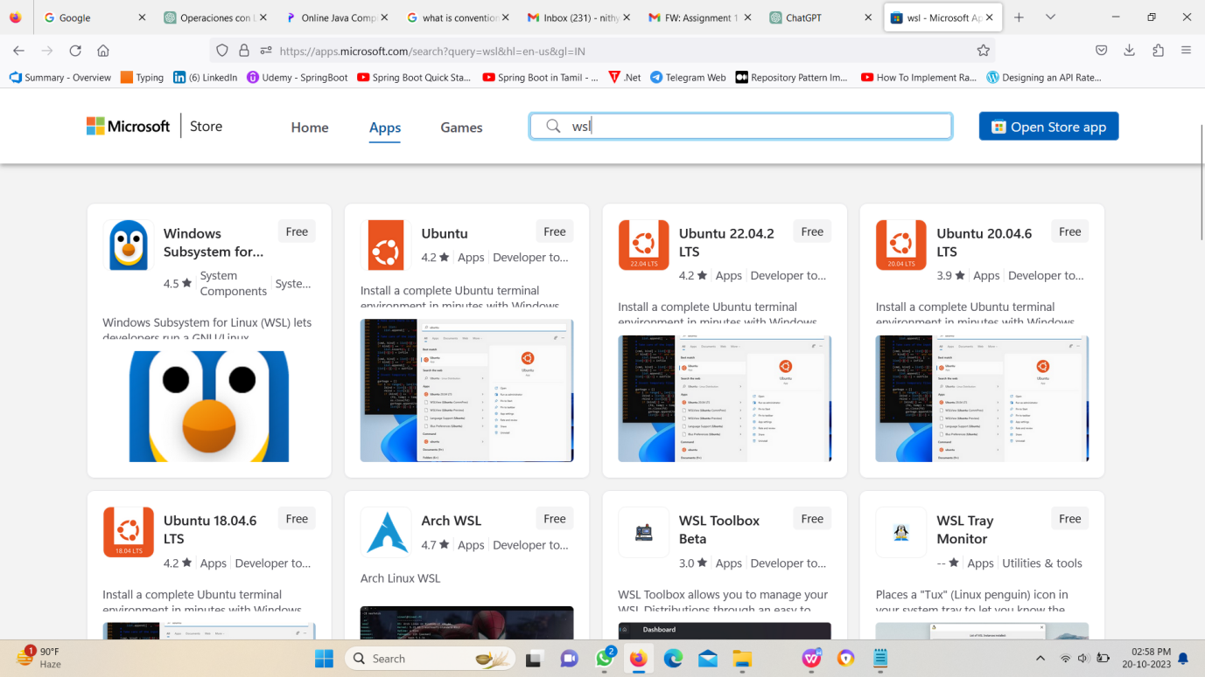

**Step 3: Install WSL**

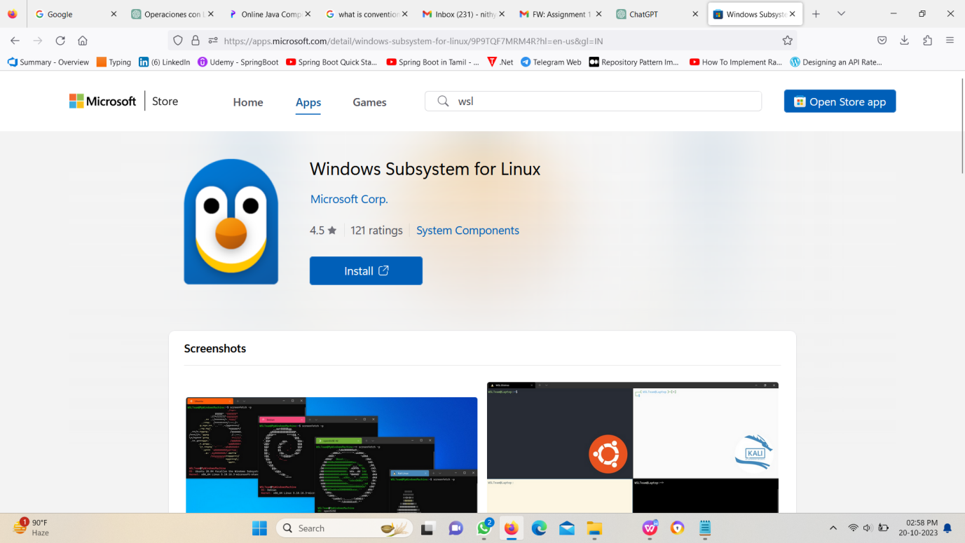

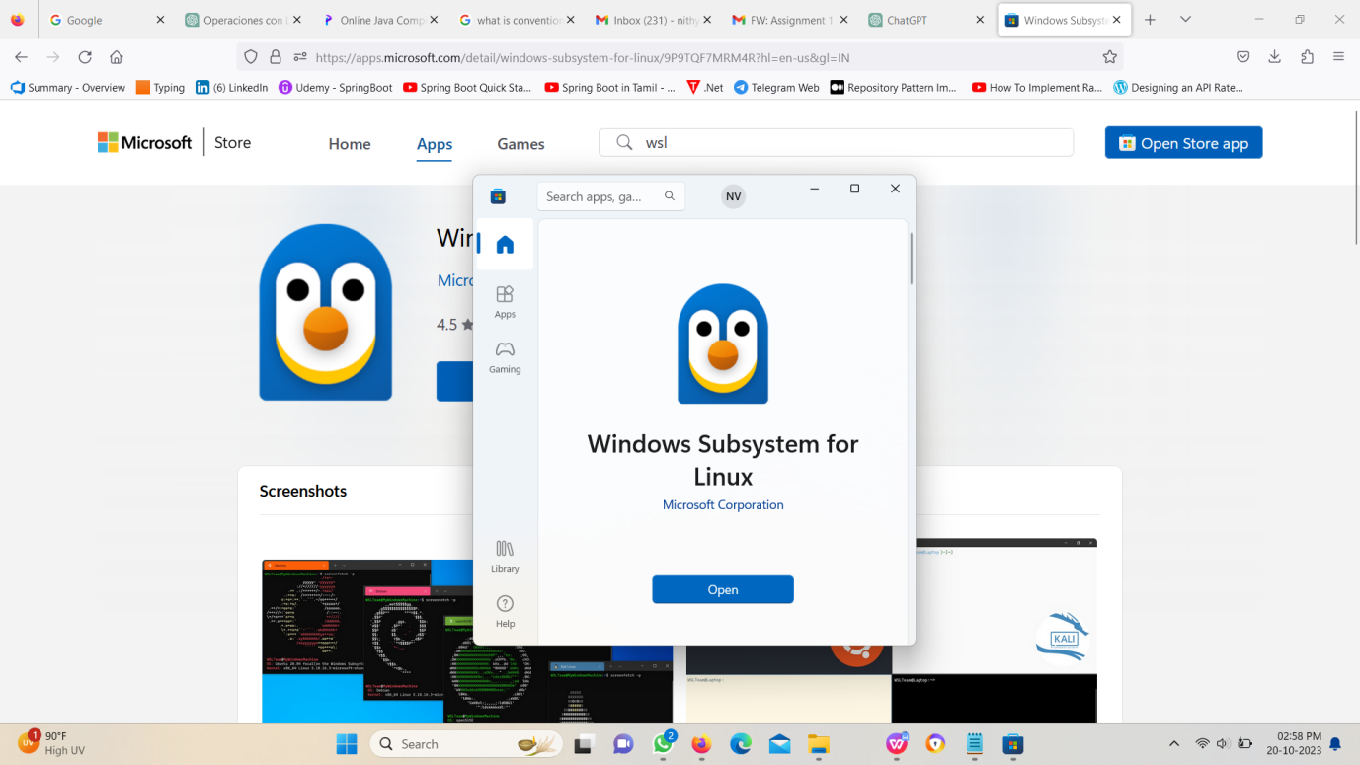

**Step 4: Install Ubuntu 20.04.6**

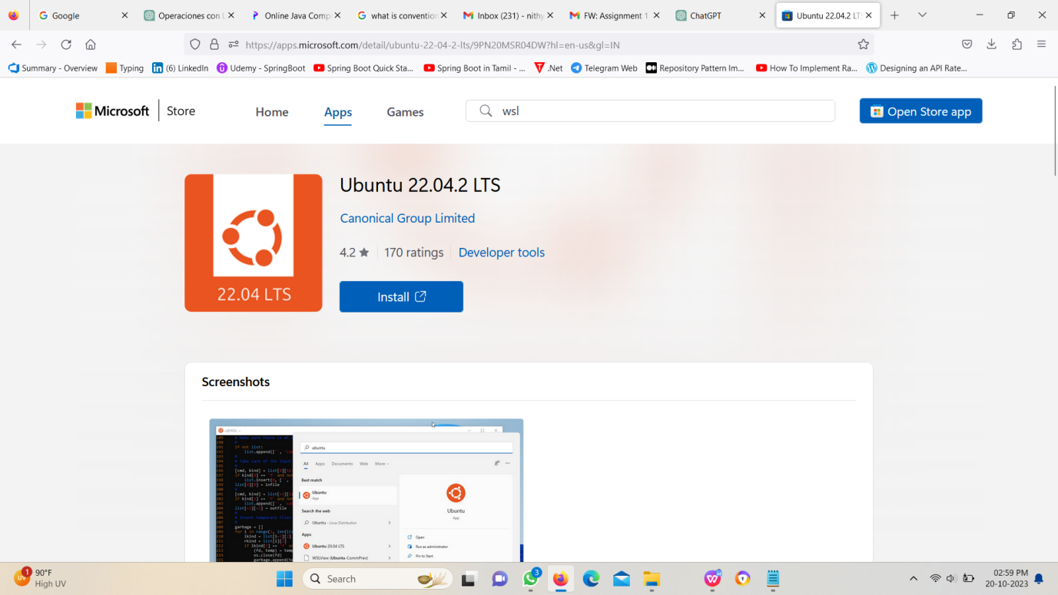

**Step 5: Open Ubuntu Give Username and Password(Note: Username should be in small letters)**

**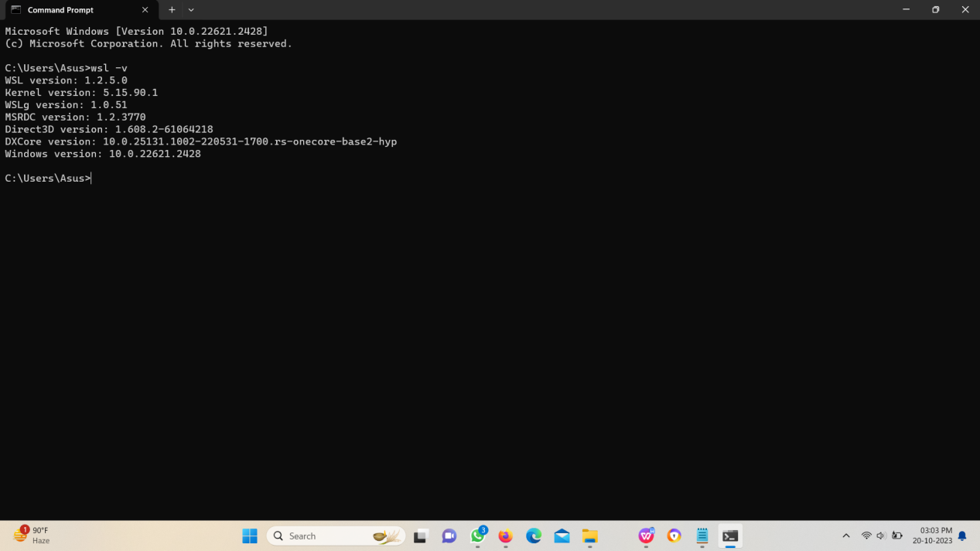**

**Lab 2: Basic Linux Commands**

· Objective: Practice basic Linux commands such as **ls**, **cd**, **mkdir**, and **touch** in a Linux terminal.

· Steps: Execute these commands and describe their outcomes.

**Ls command:**

**It will list the files and folders in the current directory.**

**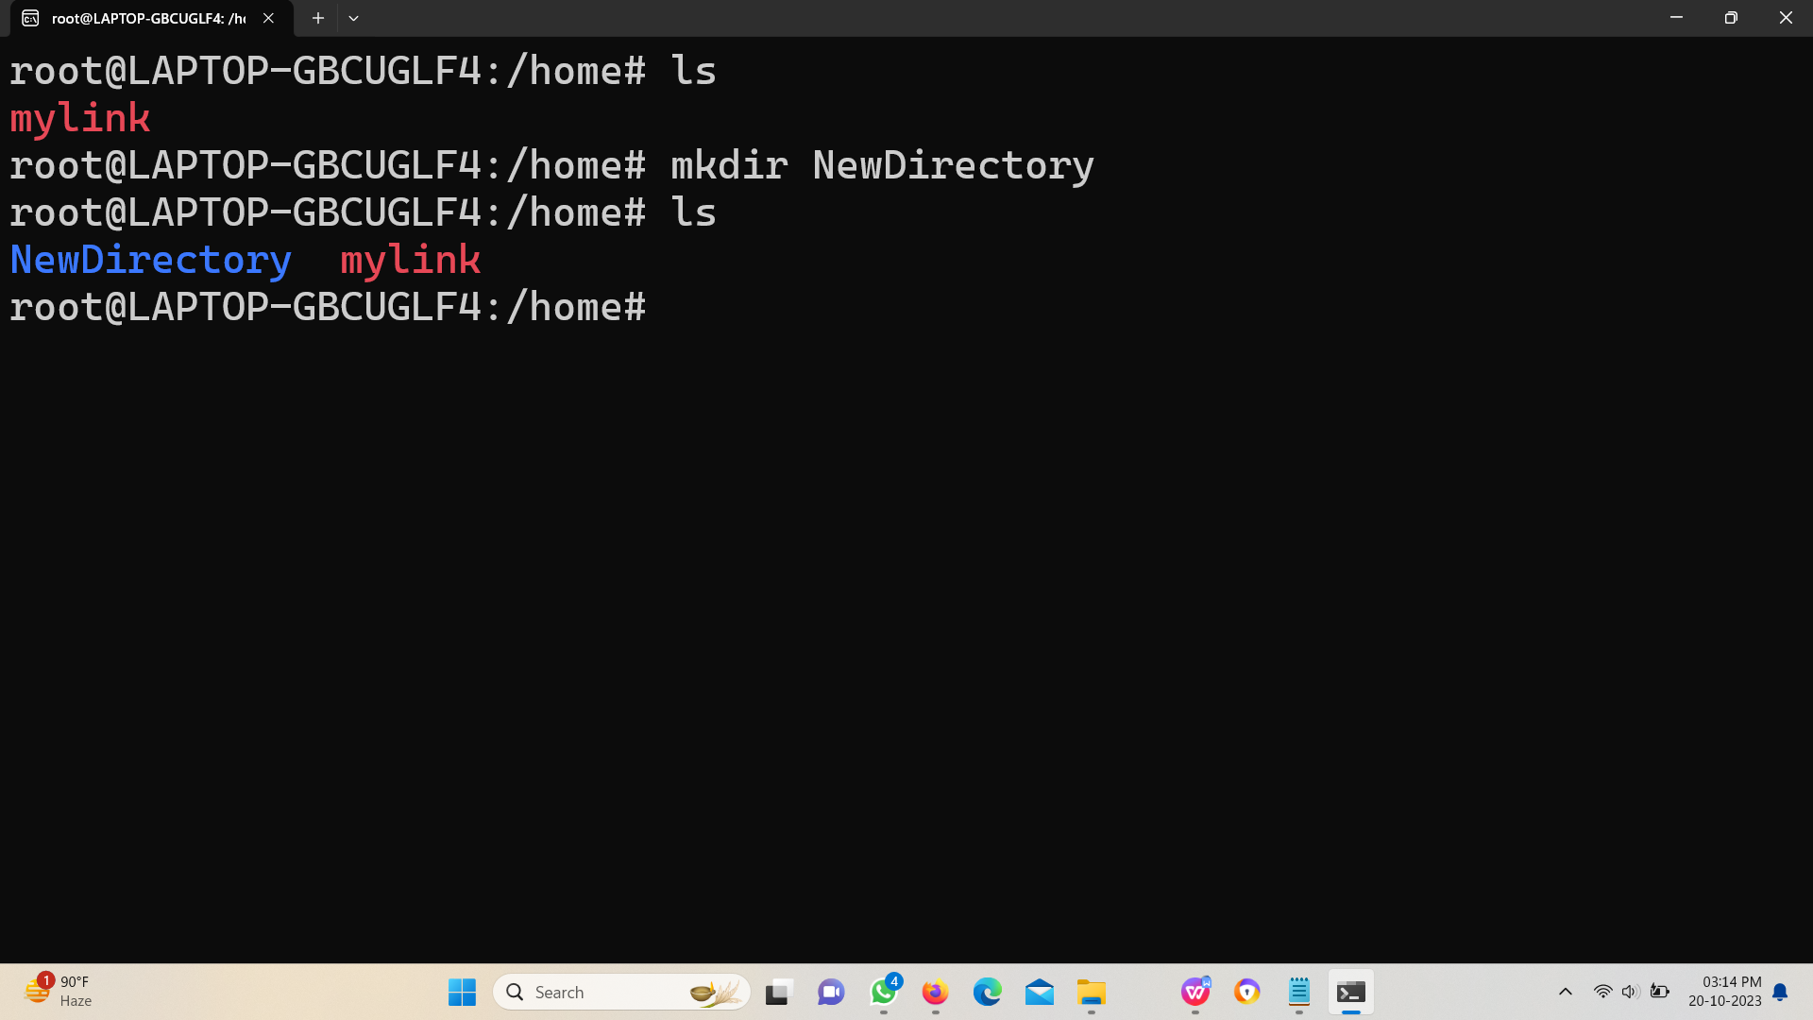**

****Mkdir Command:****

**It will create a new directory in the current directory.**

****

****Cd command:****

**It will change your present working directory.**

**Cd .. will redirect you to the parent directory.**

**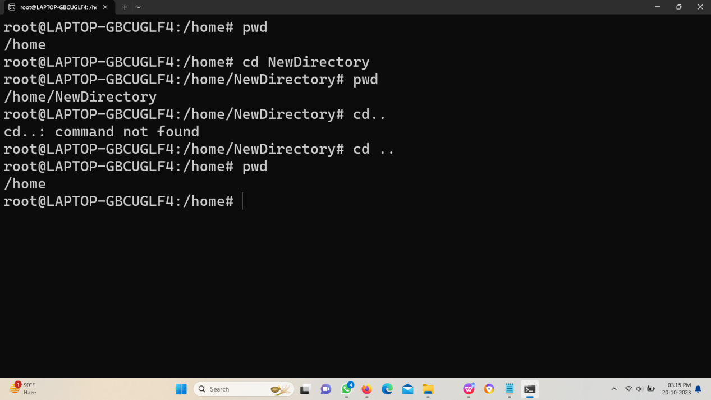**

****Touch command:****

**It will create a file in a present working directory. With the use of cat command we can read the content.**

**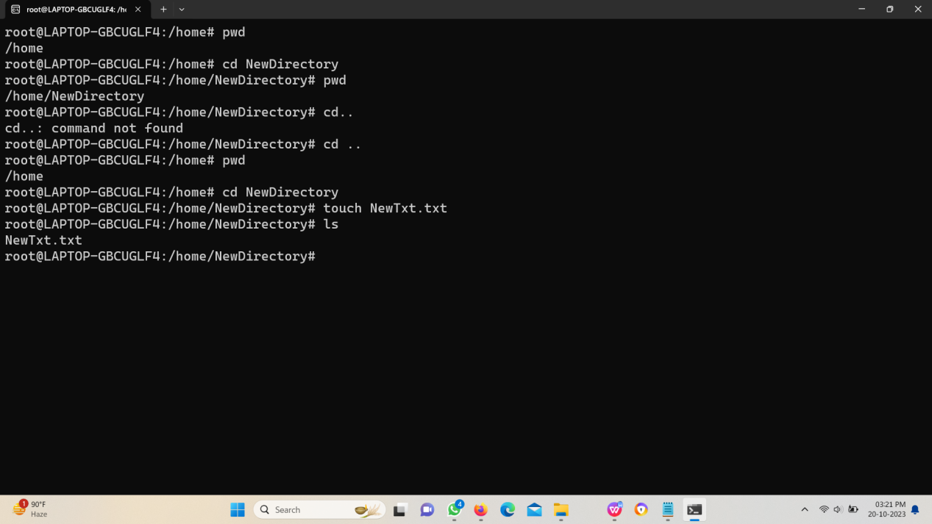**

**Lab 3: Network Configuration**

* + Objective: Configure your Linux machine to use a static IP address and Google's DNS servers.
  + Steps: Document the configuration steps and test network connectivity.

**Configuring the Linux machine to use a static IP address.**

**Step 1:** Open the Yaml file.

sudo nano /etc/netplan/01-netcfg.yaml

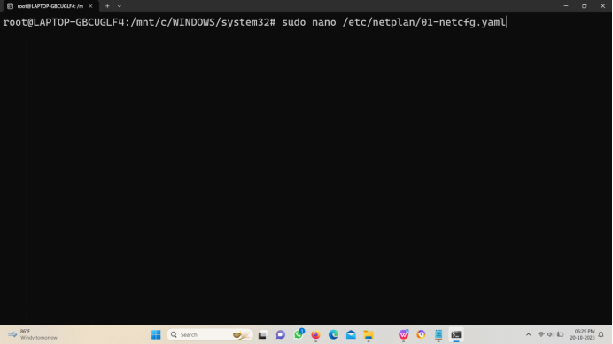

**Step 2:** Edit the Yaml file with the following code segment.

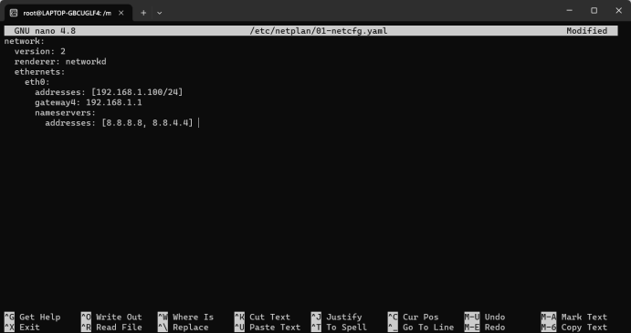

**Step 3:** Apply the changes.

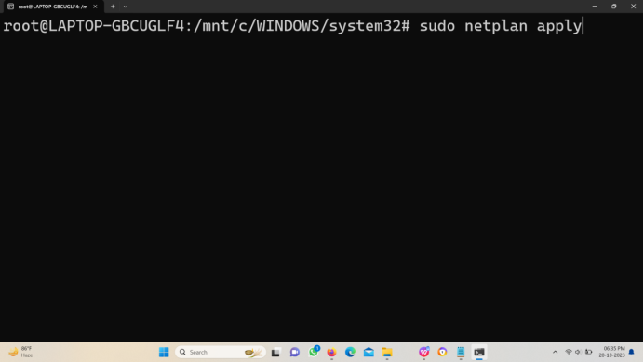

**Step 4:** Restart.

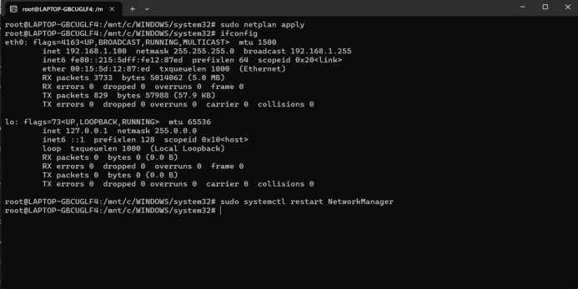

**Configuring the Linux machine to use Google's DNS servers.**

**Step 1:** sudo nano /etc/resolv.conf

Open the resolv.conf file.

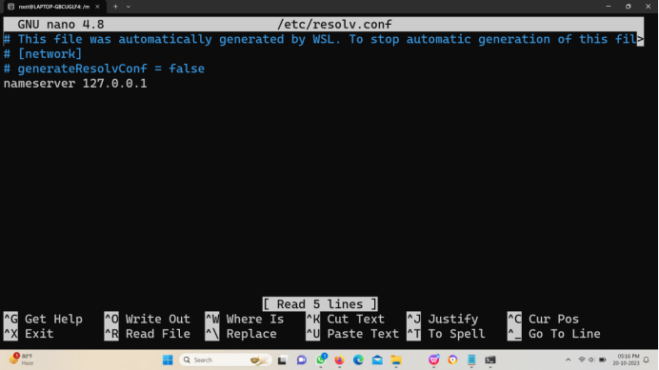

**Step 2:**

Change the address to desired. Save the file.

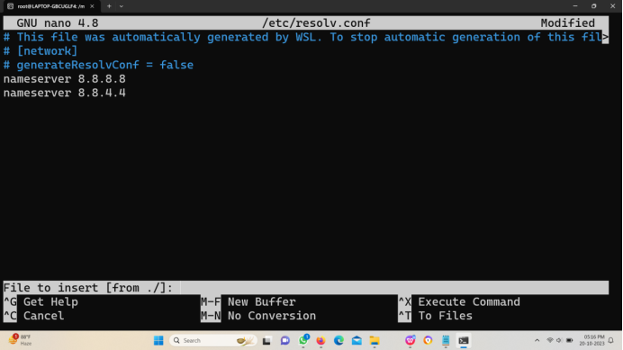

**Step 3:**

Install the network manager to restart.

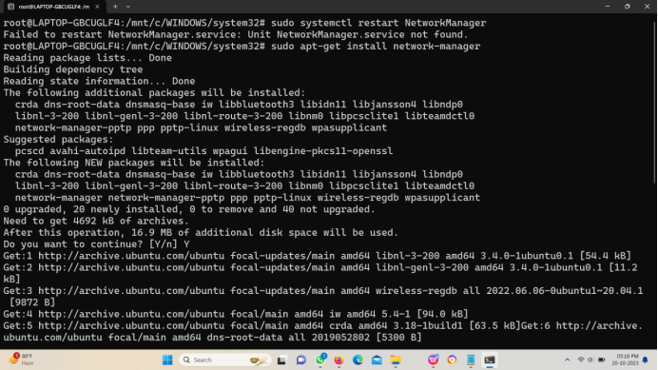

**Step 4:**

Restart. And you can review the changes in resolv.conf file.

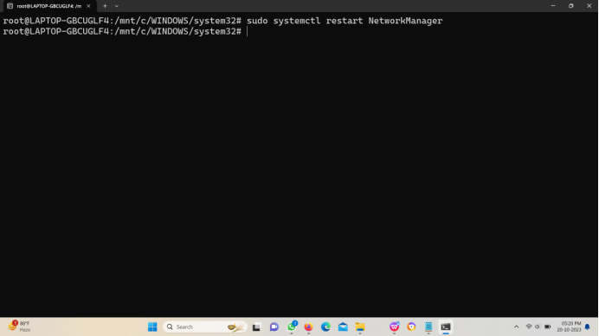

**Lab 4: File Permissions**

* + Objective: Explore file permissions by creating files and directories with different permissions settings.
  + Steps: Create and modify files with various permission settings, and describe the results.

**Step 1: Check Permissions**

* Use the ls -l command to list the files in the directory and view their permissions.

Ls -l will show the permission of the file and folders that are present in current directory.

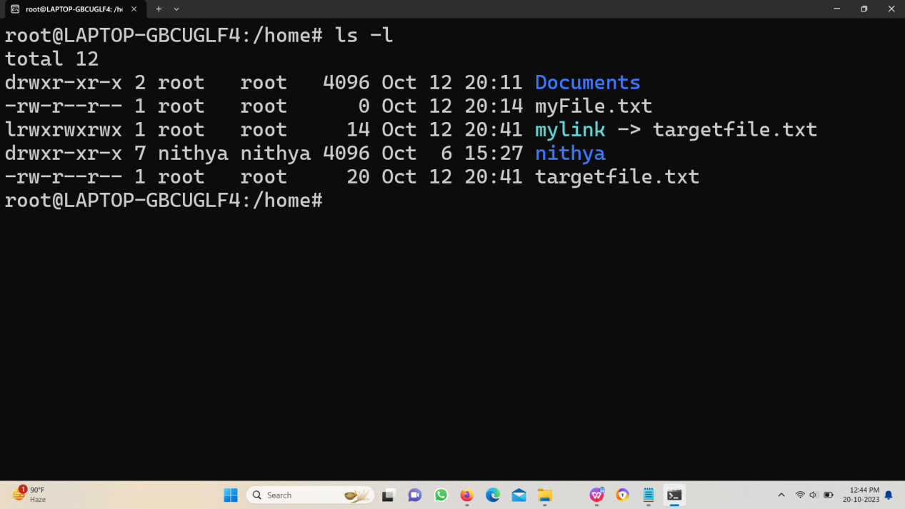

ls -l filename is used to view the permissions of a particular folder in a current folder.

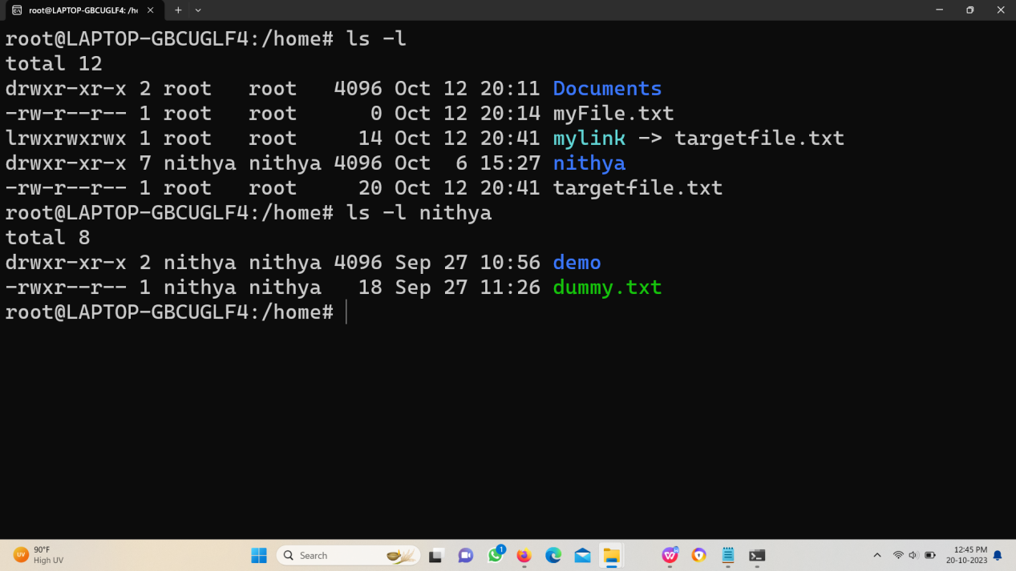

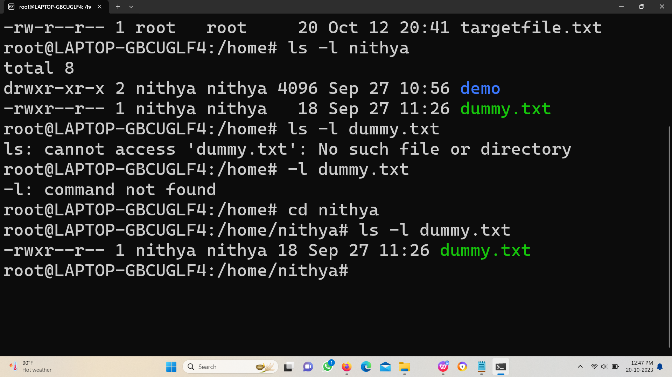

**Step 2: Modify Permissions**

* Use the chmod command to change permissions.   
    
  To change the permissions for a user, group, and others, you can use the chmod command. To grant permissions, use the "+" symbol, and to revoke them, use the "-". Use "r" for reading, "w" for writing, and "x" for executing.

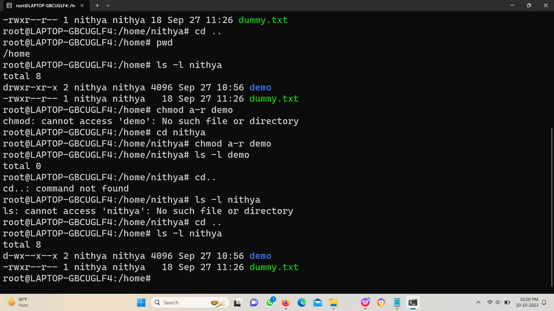

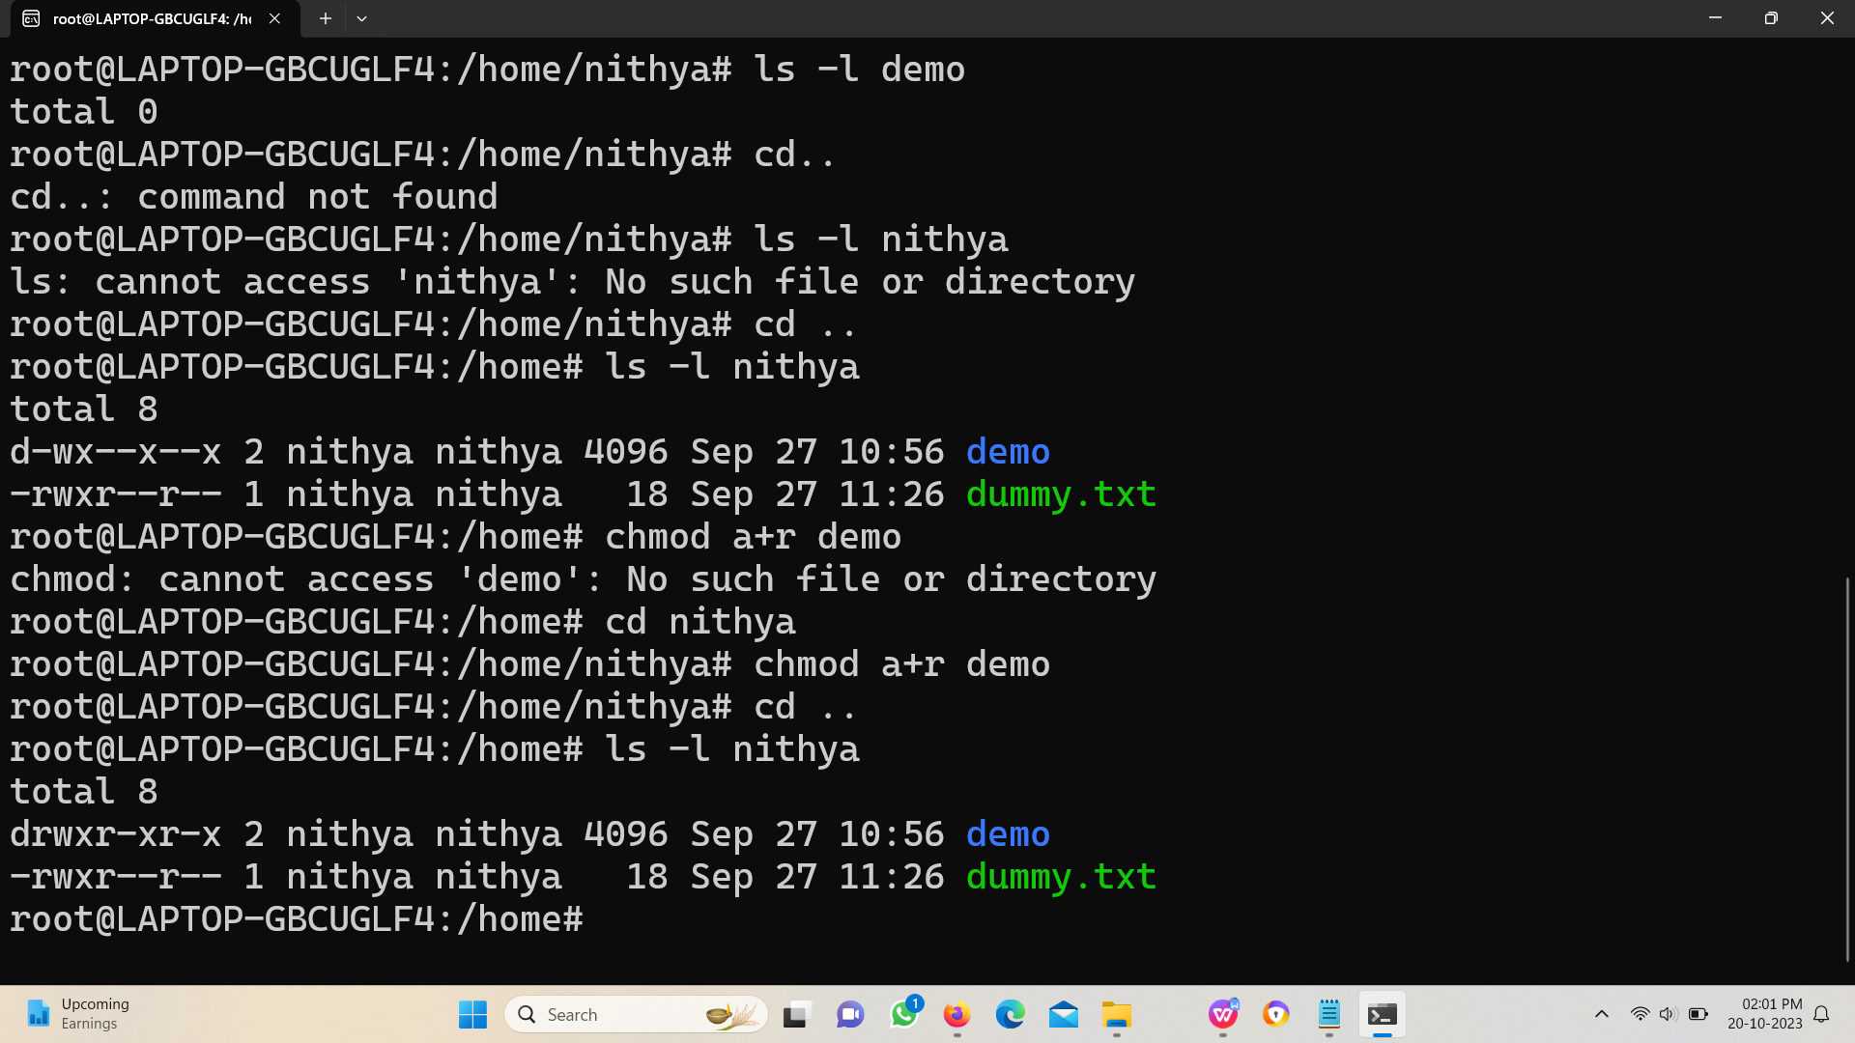

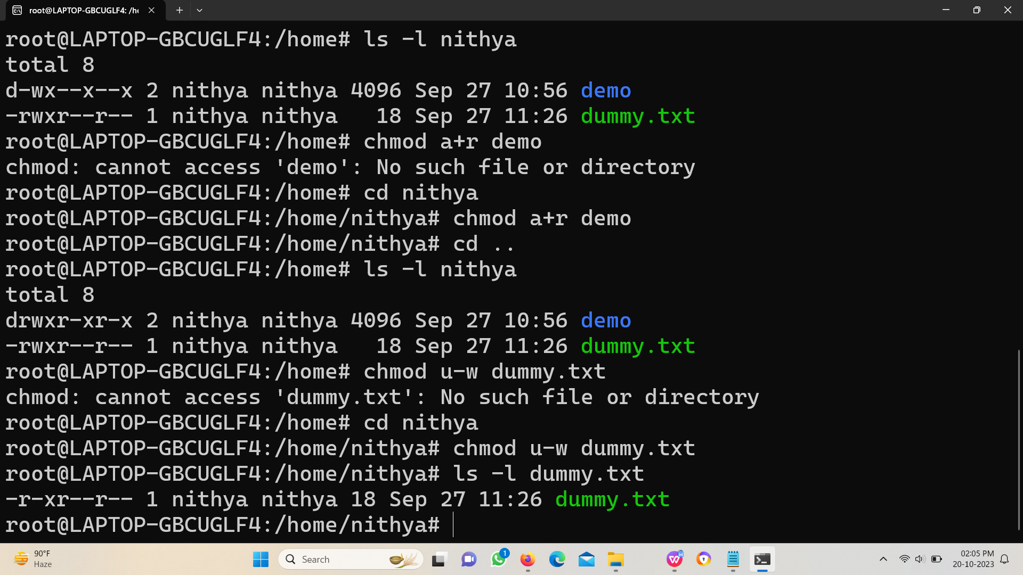

**Lab 5: Bash Scripting**

* + Objective: Write a bash script that automates a task of your choice.
  + Steps: Create the script, execute it, and explain its functionality.

Step1: Created a file named bashscript.

Step2: Addition commands written inside the file using catch command.

Step3: Make the file as executive.

Step4: Execute the file using the ./

